Cycles in Clay for Pottery of Delusion
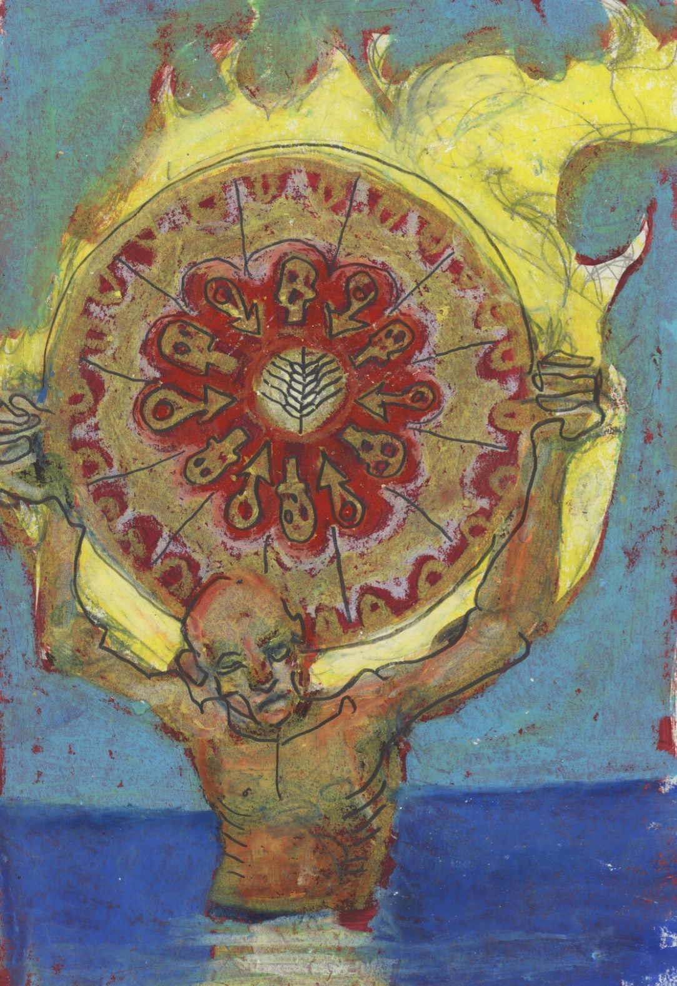
excerpts from the Encyclopedia Vol 1-7 with errata
Writing by Alia June and Art by Maufus
Table of Contents
Introduction (Sourcing The Clay) 2
Original 2
Crafted 2
Conversations with a lover (Kneading Process) 5
IX. 5
V. 6
III. 7
I. 8
VIII. 9
X. 10
XI. 11
VII 11
VI 13
III. 14
Uncertainty of Being (Basic Form) 15
I. 15
III. 16
From Love to Hate 16
V. 16
I. 17
Obsidian Mirror (Gross Manipulation) 17
XI. 17
MI. 18
Songs (Pottery) 20
III. 20
Errata 22

Introduction (Sourcing The Clay)
The following collection is separated into sections mirror to some degree the process that bore this work. Much of the work was originally authored during sleepless nights or during broken sleep, and through growing intimacy with my current lover. The collection is an exploration of trauma and my coming to terms with the trauma of my lover. The sections are as follows.

Conversations with a lover: exploration of trauma in the growing affection for another.
Uncertainty of Being: attempt to describe my condition present and past.
From Love to Hate: cycling through emotions
Obsidian Mirror: delusions which i find hard to dispel.
Songs: creative release.

What follows is a demonstration of the editing that was done. The original work was written on a mobile device and lacked any formatting, as it was stripped by the editor.

Original

I met a lady of the moor
I thought she was all alone
I don't know anymore
She collects the ghosts of those who are no longer with her
Or the ghosts of those still here
I don't know anymore
Maybe she left them all at the moor
I'm standing here and cannot find her
I'm just a ghost on her moor
I am no longer alone anymore I'm with all the ghosts of her moor

Crafted

I met a lady of the moor
I thought she was all alone
All alone
Alone

I don't know anymore
Know Anymore
Anymore

She collects the ghosts of those who are no longer with her
Or the ghosts of those still here
She collects the ghosts
The lady
The lady of the moor
Of the moor

Who are the ghosts of the moor
Who are the ghosts
The ghosts

I don't know anymore
I don't know
I don't

Maybe she left them all at the moor
The ghosts at the moor
Do they care
I don't know anymore
I don't know where she left them
I don't know

Where are the ghosts of her moor
Where are the ghosts
The ghosts

I want to know
To know
Know

I'm standing here and cannot find her
Where is she on the moor
Where are the ghosts
Where is the moor
The moor

I'm just a ghost on her moor
Just a ghost
A ghost

I am no longer alone anymore I'm with all the ghosts of her moor
No longer alone anymore
Now I know the ghosts of her moor
Now I know
I know
And I don’t care anymore
I don’t care
I don’t
I...
... the moor...
... the moor...
... the...
... I ...
...
... ah ... ah ... a ... a ... a ...
...
ah ... a ...
...
... a ...
...
...
.

Conversations with a lover (Wedging)

IX. Love and War
Join me by the water's edge,
Where the ocean meets the shore,
When the sun meets the moon .
Silver and gold reflected in your eyes,
There is no space between.
The warm winds kiss our hair.
On the pebbled ground we hide from the waves.
Like a children's game crabs go to and fro.

But we are not playing.
The long days called us here,
And here is where we will wage war,
The breath of life...
The call of death
And we have been over this...
And we will again...
We lay out our battle lines: an acumen.
The dangerous ground,
The mined fields of love.
Our lives are at stake on the cooling sand.
We go over tactics which strategies,
How will we survive,
How will we treat the wounded,
The terms of victory,
The condition of surrender,
The trials of the traitors,
And the hero’s parade.
But it is not for us...

Again, a stalemate in this intractable battle.
Then we switch sides and start again.

Your suicide attempt.

My self-destruction.

All is in ruins: there is no hope.

But you claim it's a new beginning.
I site the exhaustion.
Now you change there is the fear. reliving skirmishes,

And I claim new strength,
Back and forth again and again...
Our position in constant flux,

The reality of warfare.
But we are fighting and will continue to wage war wounded and maimed.
This is how we know we are strong enough to survive.
The breaking day will clear our minds,
And bring a lull in the fighting ,
This how we will live but we will live ,
Warriors of a cruel fate:
Kept breathing by our love .

V. For the Children
And we talked,
Where did we go?
Here we are always
leaving
There and
nowhere...
But it is a steady comfort,
That we always return .

But will they go away again?
Will they go
away forever?
Will they,

When they see you changed?

If they do, they were never really there...
If they do, they never knew you...
If they do, they loved you broken...

But did they break you,
When they said I am here to help?
Saviors, they need victims.

If I want to save you, we'll play valiant games.
Like children we’ll pretend...
We’ll take turns playing changing roles...
Heros, Villains, Innocents...
Until in the end, we're whole again.

III. Chisti
Do you believe in a dream where we can both live?
Not this hard soil, this solid ground.
But a place so far away we can only fly on the wind of breath's prayer.

The word is the eagle that never lands.

The word is our hope.

The word is a respite .

Speak so softly none can hear you.

Speak so softly all can know .

Drink the wine of houris tears...
Eden's threshold is a mystery to behold.

Pass through the lost gate...
To a garden of angels.

Behold the grapes divine.

The tree of life.
Seraphim calling "I am of the highest".

the children for angels: Dancing of the shoulders of God.

Hear the word and not be broken.

Hear the word and see history unfold.

Speak the word in broken tongues...

Speak the word with golden tongue...

The word is the breath of God.

The word is God's endless name.

One hundred one hidden from none.

Christ used the hand of God,
To pull you from the flame,
And bring you back to life.

Lazara born of angels fire:
As they touched the earth to save your life.

Now guide me for I am the lost, the lame, the blind.
Enjoin me and save my burning soul.

I. Dead
Dear one
Dead one: Shelter the deadly

Who better
To save
God's one
Angel’s wings
Embrace me

Love's failure
Stole you

What price
Silver Paid
Paid gold

you sold
your heart
And mind
And body
and soul

Dear one
Dead one: so come alive
And Stay

VIII. A love so cruel
The desert calls new life;
To survive on the murmur of the buried river.
Trace the shifting sands.
Here you lose all memory...
And are reborn.
Alone you wander.
Follower of a setting sun.
Worshiper of a hidden moon.
The skin has darkened.
The tongue is cracked dry.
But you learn to speak clearly...
You're sunken to the marrow bone,
But have strength unknown.
This is the deserts way.
Loss leads to gain.
So close to death...
You come alive,
Then find your way back again.
Perfected beyond recognition,
by the desert's cruel love...

X. For consideration of children’s games
I don't want to play,
you're in so much pain.
I don't know what to say.

You're hiding behind your hands.
I am crying inside.
I am just a child.
In my childish way,
all I can say is move your hands.

Peekaboo can I see your face?

She has stars for eyes,
A mouth so plump,
The fruit of a vine,
A smile that's divine,
from darkness rose,
But I can't see any of those.

I am at a loss .

All I can say in my childish way is:
Please move your hands.

Peekaboo Let me see your face?

She is the same,
what is inside she can't hide.
The outside tells the truth of the pain she's borne.

Now I am the same.
Bring down your hands.

I am not playing.
But all that I can say is,
Peekaboo Let me see your face ?
Peekaboo Let me see you?

XI. Listen to my dreams
my friend
will you spend the night

just to hold my hand
while I fight my battles
till I'm alright

will you hold my head in your arms
and turn back the night

my friend
will you meet me in the darkness
take my hand
and lead me into the light

my friend
stay the night
greet me in the morning
and listen to my dreams

VII. The hour before daybreak
It's early in the morning.

I have dreams to sleep.

I was hoping,
now that hope has gone.

Time still passes,
and my thoughts are the same.
It is like this every night?

No memory...

It's an idea I have,
or a wish which I want,
can't rest it is all the same.

I'm never alone,
caged in my thoughts,
the prisoner,
and their dying mate,
now the rotting corpse
of endless rumination.

The cell:
key in the lock,
and left open,
the cruel joke.

As I am shackled
by the recesses
of the brain.
And the things that can't be left
to time's past.

So I wander awake
and wonder at the sleeping kind.

It is enough to know:
some are the same,
and some are not.

Friends
and enemies
of fighters
dreaming of survival.

The morning light:
just minutes away.

So still...

That hours will pass
before day breaks.

VI. On the sea floor
I cannot sleep again.
It's beginning to take hold of me:
The shadows that form the shape of my doubt.

And a lingering sensation that I cannot name,
but is with me through time.

In truth I don't care.
The confusion defines me,
and not knowing
unfolds my terrors.
Awake, and worse:
I dream.

So a sleepless night is a respite.
The mercy of my mind
keeping the tidal waves
That are my nightmares
at lengths unknown.

To keep the sea at bay.
My ship alight I set.
In a funerary pyre I lay,
married to the depths.

The crushing waters sink me,
drowning to expose horrors
kept by time,
needing to be told.

I breathe water.
But I am trapped
on the sea floor
with the wrecks
of my dreams
and the wrecks
of all others
who cannot sleep.

Somnambulants and night dreamers awake
in fear
of the surface.

Down here
we will never see
the morning's light.

On the ocean floor
the darkness inks all
into oblivion.

I can only dream.

III. Dream Dreamer
For far long have I slept.
Night through night...
Day through day...
Dreaming and dreamless...
Hours spent on hours...
In darkness in the light...
Finally, dawn has come.

In the morning:
your face a day star,
Your heart a night sun.
Now my life has finally begun.
A loving breath that wakes my soul.
The fire of creation birthed ashes shown.

I'm untouchable in my new form.
Awaken.
A dreamer.
No longer asleep.

Uncertainty of Being (Kneeding)

I.
The colors brighten.
The dim burning.
First red then amber...
Do not forget me...
I tell myself.
If it will do any good.
Then colors of a different magnitude,
Another level,
Who am I again?
It can't be me; I am always in pain.
...
I feel nothing.
Maybe I am you, my friend?
You never mind the reasons less.
Will you be me so I can see if it is true?
I've been gone for days, and know:
the time between time when nothing is expected.
Now turn slightly, I can see me.
You are me.
Very well then...
I can do anything I want.
You can't hurt me.
And I cannot hurt myself.
...being no one is the safest way.

III. Transformation at Zero-Hour

I do not know
I have never been
I will never be
And
My heart
Sought and bought
Underhand and underhand
to a new land
My Mind
Bound don’t misunderstand
Reason untold
until I no longer know
My body
Open and bare
My soul
Untouched
It is mine and mine alone
And have always known
I have always been
I will always be

From Love to Hate (Basic Form)

V. Golden Our
Take the road of gold

And behold the silver land

Understand it lives in us all
Here we can finally rest

It is not a dream
Your heart is a shimmering flower
A follower of love's desire

Your pain is the shade
Under which orchids grow
In this shelter
Blooming flowers

I. Crystal Flow
Icicle crystal,
hanging lower and lower.
In the window,
Shimmering in the daylight.
Is this your pure heart... thawing.
Glowing brighter and brighter.
Meet me in the morning by your window,
There is an icicle melting slowly.

Obsidian Mirror (Gross Manipulation)

XI.
true believer
come dance with the golden calf
with heart of gold
and golden heart

come dance all night
with love of gold
and golden love

by the morning light
with hands of gold
and golden hands

on the golden throne
with chains of gold

come dance with the golden calf
come dance all night
by the morning light

on the golden throne
we’ll see you
believe it’s true
true believer

Songs (Pottery)

III.
driver
drive driven
its zero hour

drive
driven driver
till metropolis down

drive and drive
in a night so full

reflecting the moon open on the asphalt.
The failing stars dying on the city skyline

its always somewhere... let’s go...

Metropolis sets to a neon glow.

People walk by silent beyond the glass...
They are to look at but no more.

driver
drive driven
its zero hour

drive
driven driver
till metropolis down

Drive driven driver through this full lit night,
An open moon broken on the asphalt,
The dying stars in the failing city skyline ,
There is... always... Let's go... somewhere ... let's go.
metropolis neon burn set a glow.
Glass... people... walk... silent beyond...
Look. they are no more...
Let's ride...

Driver drive all night.
Leave metropolis behind.
The asphalt, the moon, the stars, the neon glow.
The horizon Falling past.
drive driver drive... in this car.
Driver... drive... let's ride.
Leave the people... silent behind glass.
Let's go.

driver
drive driven
its zero hour

drive
driven driver
till metropolis down

Glowing neon asphalt moon...
Stars lined skies falling soon
Metropolis failing behind...
Dying glass beyond...
There's Somewhere...
And always...
Walk... silent... people.
No More... and more.
Driver...
Go...
Drive...
Driven lets ride

Metropolis drive the neon mind.
Metropolis a falling star past the skyline.
Metropolis the moon glowing glass silent burn...
Metropolis the people beyond...
Metropolis drive and drive the driver more and more...
Metropolis... down the line...
Metropolis drive the driver ... down...
Metropolis let's go... down...
Metropolis... down...
Metropolis....

Errata
I dream of a machine mirror,
or will it hallucinate with me,
not reflecting but distorting,
how can I dream when I barely know,
how can I see a reflection when I do not know myself,
how could I be what I see in this machine,
so real so living,
a dead computational recursion eating all meaning

This document presents the final determination of my machine-learning instrumentation for anti-hallucination protocols: protocols designed to mitigate hallucination within machine-learning engines.

This material is included because machine learning was used to test interpretations of the poetry contained within this work. In the absence of an editor or audience, a machine mirror was created: a system intended not to generate new content, but to reflect the existing content back to the writer.

For that mirror to be useful, machine hallucinations had to be carefully mitigated. This was especially necessary because the source material is abstract and emerged from a period of mental instability, making source fidelity, interpretive restraint, and non-invention essential to the process.

